# Database Mgmt. & Warehousing

Case 1  
A00247163

Kushal Vaghani

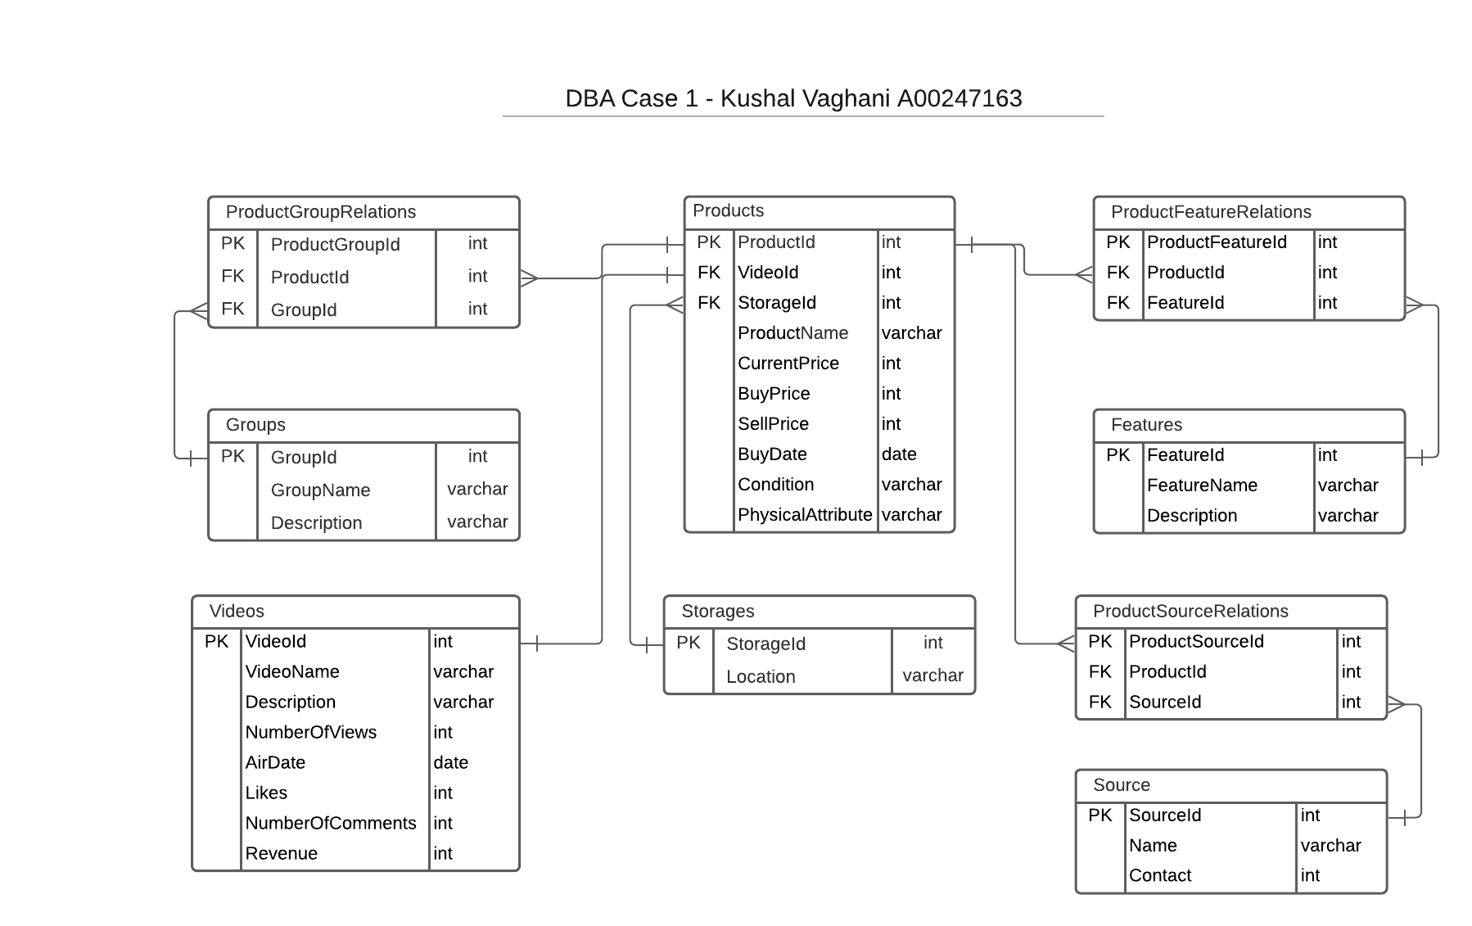

**Case summary**

The main component of the above case is the product where different products are bought from different sources. Once, the product has arrived the next stage of the process starts which is to know the features (along with any faults) of the product, if the product is like any previously posted video it is grouped in the same category (for features comparison and to store) and the video is prepared to be posted on YouTube. The last stage after posting the video is to sell the product, if not sold the item is then stored at a storage facility.

**Benefits of the above model**

* The above model would be helpful to keep track of each product with its unique id. If the model is implemented it will be easy to store, sell and keep track of product condition. It will also make it easy to compare which manufacturer/source is more reliable for future buying of products and keep track of pricing for each product.
* Helps to identify and search based on each of the product features and decide if there are any similarities with a different product. The products can also be grouped if they fall under similar categories which will help to make product comparison videos.
* It’d also help to keep track of each video posted on YouTube with how many views the video gets, the description posted with each video, what date it was posted on, and how much interaction each of the videos receives e.g., the number of views, likes, and the number of comments.
* It will also keep track of the revenue that each video generates, which will help to prepare for future videos and to keep track of what product video viewers are interested to watch more based on the video engagement. It will also help decide what day is the most beneficial to post a new video on as the model keeps track of the date a video is posted.
* The model is built such that it can easily track the date the product was purchased, and the price that the product was purchased for. It also keeps a record of the current price of the item, and if the item was sold it also records the selling price which can be beneficial to track profit/loss over time. If the product is still in inventory at the storage facility each product will have its location saved with which it can be easily retrieved.

Overall, the model is a robust system that can track all the products from the time its sourced from the seller/manufacturer, keep track of the price, features of the product, helps to group them under the category, the revenue it generates, the engagement each video gets and finally the location of the item at the storage facility.

**The products table**

The products table keeps a record of each of the products, the current price, the price the item was bought at, the selling price, the date the product was bought, the current condition of the product, and the physical attributes of the products.

**The Features table**

The features table keeps track of the features (with any faults) of each product, and the description of the feature. One product can have many features. Since many products will have many features there is a many-to-many relation for which there is a *productfeaturerelations* table.

**The sources table**

The sources table keeps track of the product that it was bought from (implied that if it’s a new item, the source will be the manufacturer of the product). It also holds the seller’s name and the contact number. Different products are sourced from different sources and that is the reason for many to many relations. Which is implemented with a *productsourcerelations* table.

**The groups’ table**

There will be many products that fall under the same category for which they can be saved under a group. The groups’ table keeps track of the group name and the description. As there will be many different groups and many different products there is a many-to-many relation for which there is a *productgrouprelations* table.

**The videos table**

The videos table keeps track of each product video and at present, the model is built such that each product will have one video, which holds the video name, description, number of views, the date it was posted on, likes, comments and the revenue the video generates. Since one product will have one video (assumed during building the above case) it has a one-to-one relation with the product table.

**The storages table**

The storage table keeps track of the storage location where each product is stored. Since there is only one storage facility (assumed during building the above case) there is a one-to-many relation (one storage facility will hold many different products).